MedCommons C# CXP SOAP Client

CXP 1.0
3/2/2006

The C# CXP SOAP is a small sample program that demonstrates how to invoke the CXP 1.0 SOAP interface.

Currently only two SOAP calls are supported in this sample: PUT and GET.
.

Installing the program
Unzip the file and open the cxp_10.csproj in Visual Studio.

Configuring the program
Typically this program does not need to be configured. If you want to point at a host other than
https://gateway001.medcommons.net/router/services/CXP
then follow these steps:
- Open the Solution Explorer and select CXP:
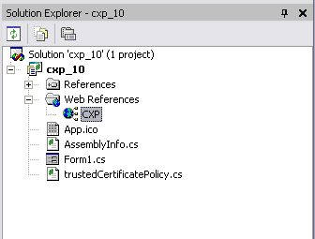
- Right click and select Properties from the menu.
- Enter the URL of the WDSL for the new SOAP endpoint.
- Press Enter. The following dialog box appears:
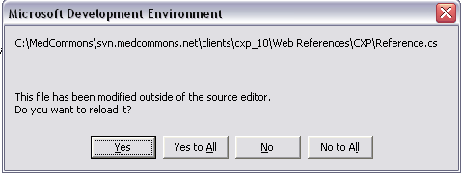
Select “Yes to All”.
- Now press the F5 key to start the debugger. The following window appears:
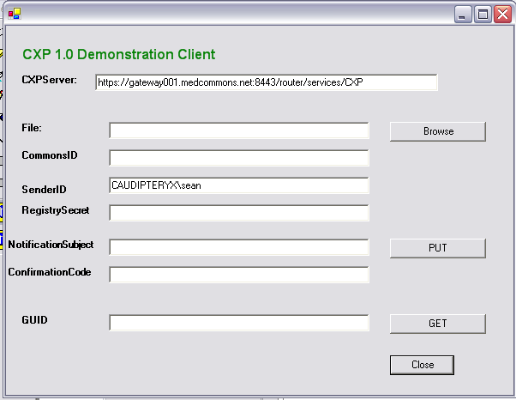
The SenderID is automatically filled in with your user login information.
- Click on the browse button to select a CCR, then click the PUT button. This transmits the CCR to the server. If the CCR contains validation errors then these will be enumerated in a status display dialog.
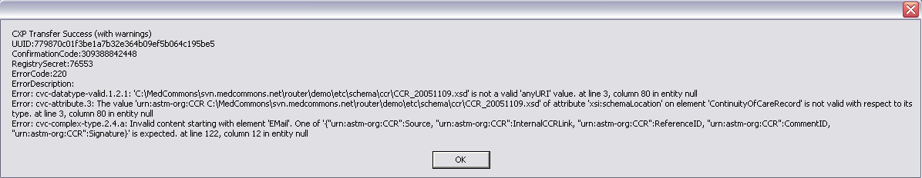
- The application dialog box automatically has the ConfirmationCode and RegistrySecret filled in:
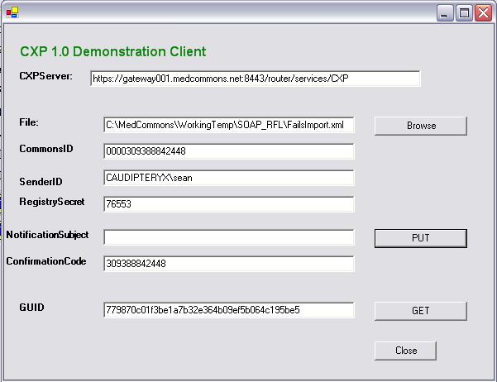
- Clicking the “Get CCR” button will now retrieve the CCR for this ConfirmationCode and RegistrySecret.
- 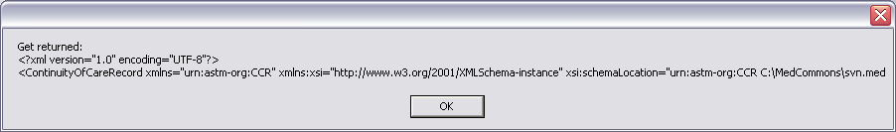
Only the first 200 characters of the CCR are displayed. In a real application the CCR would be saved to disk or would be imported into the application.

